Gabriel Emerson

ELEC 2210 – T 11:00

Experiment #7 Bipolar Junction Transistors

03/02/2021

**Introduction:**

The goal of this lab is to take the knowledge of bipolar junction transistors the student has gained from lectures and apply them to a physical circuit. A 2N3904 NPN BJT will be used to assemble said circuit. This lab will help students visualize concepts gained from the classroom and will further solidify the BJT’s significance in current amplification.

**Part 1: Forced IB Output Characteristics**

The 2N3904 NPN BJT was connected onto the NI ELVIS board, making sure the collector was inserted into DUT+, the emitter into DUT, and the base into BASE. Using the 3-wire current voltage analyzer, the forced base current output characterizers were measured. Then, using the data from this plot, another graph was generated that plotted βF vs VCE. The forward and saturation regions are shown in the figures below.

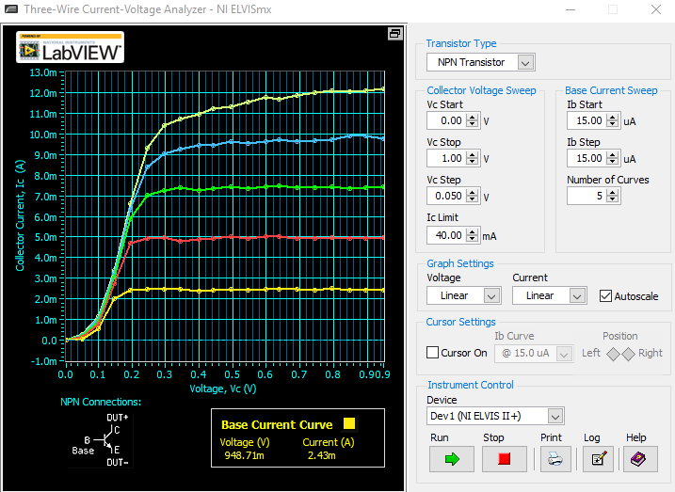

Figure 1: Forced IB Characteristics

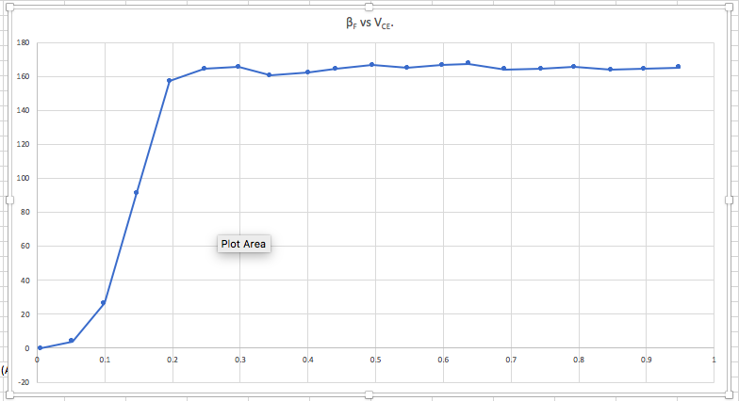

Figure 2: βF vs VCE Plot

**Part 2: Forced V­BE Output Characteristics**

Using a 2N3904 NPN transistor, we measured the forced VBE­ output characteristics of the transistor. Due to the analog outputs having a very small current capacity, two non-inverting unity gain op-amps were used to achieve the measurements. The reaults can be seen below, along with the saturation and forward regions.

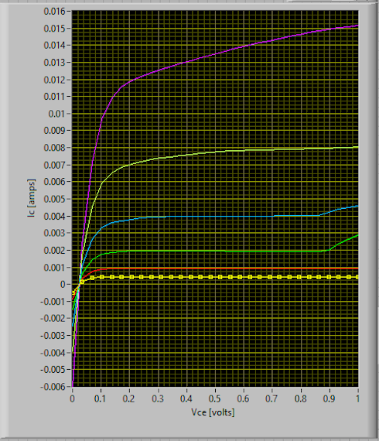

Figure 3

**Part 3: NPN Transistor Switching Characteristics**

Using a 2N3904 NPN BJT and a few resistors, we created a simple circuit. Then, using probes and the LabVIEW simulator, we generated voltage transfer curves for different locations in the circuit. AO0 was used as the programmable input voltage and was swept from from 0-5V in a 100 step increment. A screenshot was taken of each of the graphs and they can be seen below.

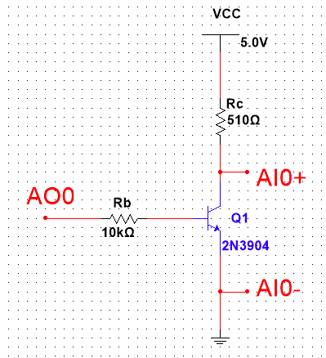

Figure 4: Circuit Schematic

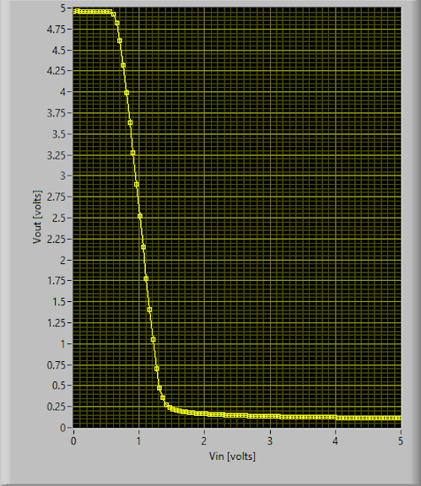

Figure 5: VCE vs Vin

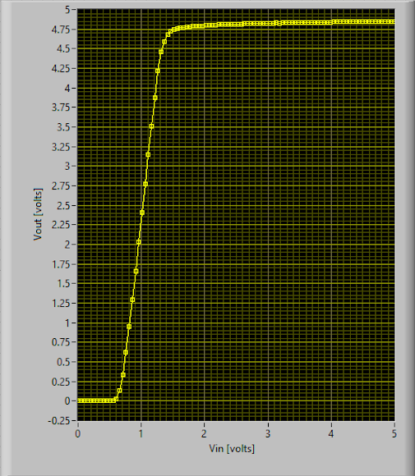

Figure 6: V C-Load-Resistor vs Vin

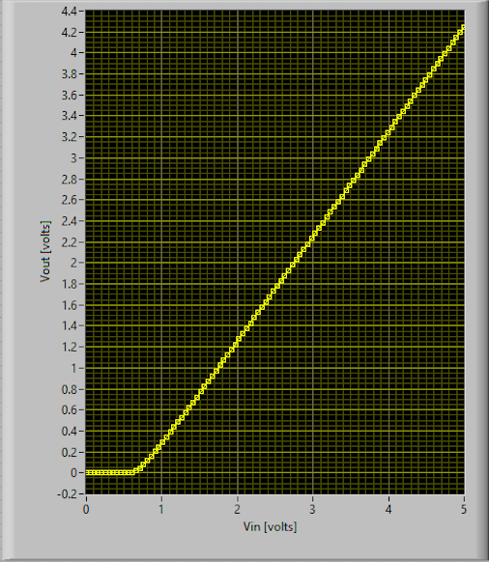

Figure 7:VB-Resistor vs V­in

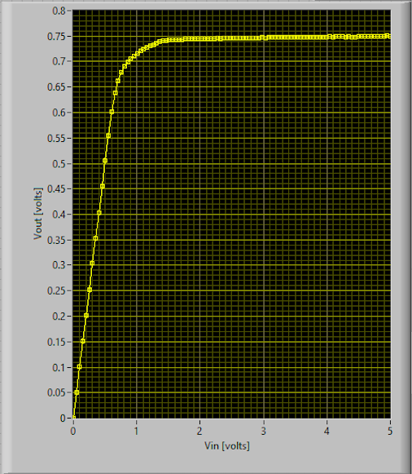

Figure 8: VBE vs Vin

The output voltage seems to drop appreciably around ~0.6-0.65V in Figure 5. This value is close to the turn on voltage of 0.7V for a Si PN junction. This follows sound logic as the base-emitter junction is essentially a PN junction. The cut-off mode of operation begins at 0 and lasts until ~0.6-0.65V. Saturation mode occurs during the interval of ~0.65- ~1.5V. Forward mode occurs from ~1.5V onward.

Using data from the plots above, a graph can be generated that plots IC and IB against Vin. From the graph, as Vin increases, Beta decreases. This can be determined using the IC/IB values as V­in increases.

**Part 4: Transistor as a Switch**

Using the lab manual schematic, a circuit was built with the 2N3904 NPN BJT, some resistors, and an LED. With the multimeter and digital writer, measurements were taken for several variables when the LED was on and when the LED was off. This data implies that the transistor was in saturation mode when the LED was on. Furthermore, it also showed that the transistor was in cutoff mode when the LED was off.

|  |  |  |  |  |  |
| --- | --- | --- | --- | --- | --- |
| LED | VCE | VBE | VBC | I­B | IC |
| ON | 0.107 | 0.706 | 0.648 | 0.00042 | 0.009174 |
| OFF | 3.66 | 0 | -3.6 | 0 | 0 |
| FAN | VCE | VBE | VBC | I­B | IC |
| ON | 0.107 | 0.83 | 0.704 | 0.003997 | 0.087306 |
| OFF | 4.64 | 0 | -4.64 | 0 | 0 |

**Conclusion:**

This lab allowed me to have a better understanding of the BJTs that we have discussed in class. I had an issue with a faulty transistor, but other than that the lab went well and I had no issues. Part 3 had the biggest impact on me. I really appreciated being able to see the voltage characteristics at each point in the circuit. I wish I would have grasped this concept sooner. I also think that this lab allowed me to further my intuition skills when determining if the BJT is in forward or saturation mode.

